



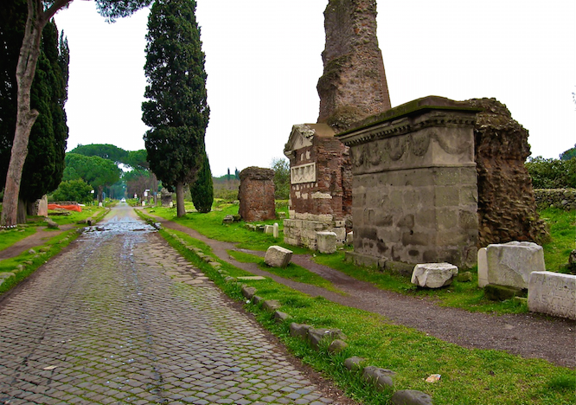
Third Sunday of Advent: God is faithful to empower us to live holy lives as we await God’s kingdom
1 Thess 4:3 NRSV “… for this is the will of god, your sanctification (ἁγιασμὸς): that you abstain (ἀπέχω) from sexual immorality…”

1 Thess 5: 16-23 NRSV “Rejoice always, ¹⁷ pray without ceasing, ¹⁸ give thanks in all circumstances, for this is the will of God in Christ Jesus for you. ¹⁹ Do not quench the Spirit. ²⁰ Do not despise prophecies, ²¹ but test everything; hold fast (κατέχω) to what is good; ²² abstain (ἀπέχω) from every form of evil.

May the God of peace himself sanctify (ἁγιάσαι) you entirely, and may your spirit and soul and body be kept sound and blameless at the coming of our Lord Jesus Christ.

Purpose of 1 Thessalonians
“Brothers and sisters, we want you to know about people who have died so that you won’t mourn like others who don’t have any hope. ¹⁴ Since we believe that Jesus died and rose, so we also believe that God will bring with him those who have died in Jesus. – 1 Thess 4:13-14
1 Thessalonians 5:16-24
Rejoice always. ¹⁷ Pray continually. ¹⁸ Give thanks in every situation because this is God’s will for you in Christ Jesus. ¹⁹ Don’t suppress the Spirit. ²⁰ Don’t brush off Spirit-inspired messages, ²¹ but examine everything carefully and hang on to what is good. ²² Avoid every kind of evil. ²³ Now, may the God of peace himself cause you to be completely dedicated to him; and may your spirit, soul, and body be kept intact and blameless at our Lord Jesus Christ’s coming. ²⁴ The one who is calling you is faithful and will do this.

